A Systematic Survey of Loss-of-Function Variants in Human Genome: Update 2019

Abstract

putative LoF (nonsense, splice-disrupting, frameshift and NsynD6/12) variants in protein coding genes

125,748 exomes and 15,708 genomes

It was estimated human genome contains ~100 genuine LoF variants with ~20 genes completely inactivated (1).

We need to answer these questions:

1. What’s the difference between LOFTEE and ALoFT for the annotation to loss-of-function to ExAC dataset?
2. How much exactly loss-of-function variation in human variants catalog?

LOFTEE

ALoFT and LOFTEE

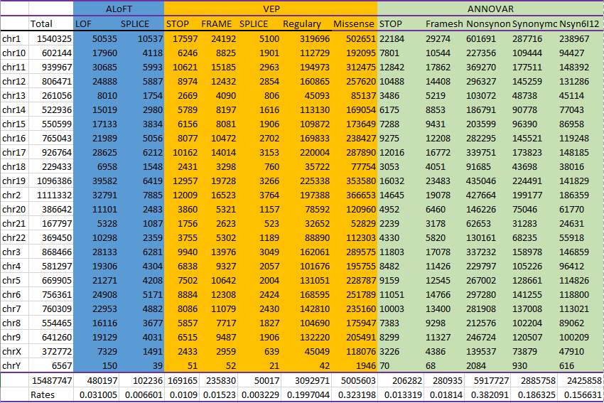

Methods

Dataset. <ftp://ftp.1000genomes.ebi.ac.uk/vol1/ftp/phase3/integrated_sv_map/ALL.wgs.mergedSV.v8.20130502.svs.genotypes.vcf.gz>

<ftp://ftp.1000genomes.ebi.ac.uk/vol1/ftp/phase3/integrated_sv_map/ALL.wgs.mergedSV.v8.20130502.svs.genotypes.vcf.gz.tbi>

Software. LOFTEE

1. MacArthur DG, Balasubramanian S, Frankish A, Huang N, Morris J, Walter K, Jostins L, et al. A systematic survey of loss-of-function variants in human protein-coding genes. Science 2012;335:823-828.